PRACTICAL 1

1. Aim: Introduction to User Interface (UI) life cycle and UI tools
2. Description:

User Interface:-

The user interface (UI) is the point at which human users interact with a computer, website or application. The goal of effective UI is to make the user's experience easy and intuitive, requiring minimum effort on the user's part to receive the maximum desired outcome. User interface (UI) is the space where interactions between humans and machines occur. The goal of this interaction is to allow effective operation and control of the machine from the human end, whilst the machine simultaneously feeds back information that aids the operators' decision-making process.

User Interface design process:-

User interface development process can be categorized into 4 phases :-

* Research and Analysis
* Design and Branding
* Prototype Development
* Production

This structured process can maximize communication between the company and its clients, lower development costs, and most importantly deliver the best user interface design.

This process is flexible and modular, thus allowing client to determine which phases are appropriate for their needs, and can be applied to both the creation of user interfaces for new applications as well as enhancements of existing applications.

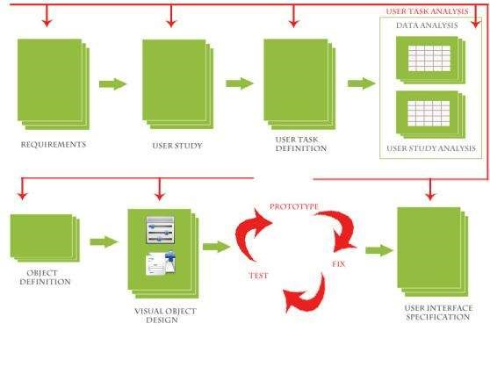

A. Research and Analysis

This establishes the context for User Interface design and this context informs the entire design process. Additionally, during this phase as a part of UI development, UI developers can start researching current market trends, UI technologies, and competitive analysis. This research can help the UX team during the consecutive phase of SDLC and both UI and UX team will have clarity of things possible and impossible and LOE (level of effort) required during development. Deliverables

* Personas
* Competitive landscape
* Usability goals
* Functional and non functional specifications

B. Design and Branding

During the design and branding phase, User Interface design is created that addresses the specific needs identified in the research & analysis phase and creates, revise or leverage the applications brand.

Deliverables

● A discussion of the design philosophy and strategy used to create the UI design, including an explanation of how research brief informed the UI design ● A comprehensive set of screen layouts illustrating every part of the UI design ● Key screen that presents the visual design and branding for the application.

C. Prototype development

Using the approved design document as blueprint, prototypes of the User Interface designs are created. Based on clients needs the prototypes are created using HTML or flash. Prototypes can be low fidelity or high fidelity based on user needs.

The scope of the prototype created during this phase is tailored to the specific application and the user testing requirements. Some applications require a comprehensive click through or working model of the entire interface, while others only require a prototype of core functionality.

The prototype serves as

* A communication and review tool for the client
* An implementation guide for the software developer
* A user testing tool
* A working prototype enables clients to see how the user interface will perform without having a commit programming resource

Deliverables

* Interactive prototype of the new user interface

D. Production

A proper UI and UX team collaboration and Integration of UI design from the starting of SDLC can reduce a lot of efforts and confusion. Also it can help in successful and timely delivery of the products in any company without any slippages and can increase customer satisfaction. Additionally it can help build ongoing relations with our clients.

UI Tools:

UI and UX are two distinct facets of web design, yet they work hand-in-hand. While UI focuses on your design interface and how a user interacts with it, UX emphasizes a user's experience as they use your product or service. UI design tools give designers what they need to design accurate hi-fi wireframes, mockups, and prototypes and render minimally viable products. They represent the nuts and bolts of a design, communicating its functionality. UX design tools focus on the user and how they’ll experience the content. These tools can help structure the information architecture, as well as how someone will flow through the experience.

* Adobe XD :

Adobe XD is a powerful and free wireframing tool for UI/UX designers, built by the world’s leader in creative technologies. With XD, you can quickly mock up and wireframe layouts, create UI elements and define user flowcharts, navigational structure and information architecture - all in one design tool.

* Axure :

Axure functions in prototyping and keeping track of the workflow. It features a smooth interface to document as you go. High fidelity drives this app, resulting in prototypes full of details. Axure offers many of the other features of popular prototyping and UI design tools. It allows for testing of functionality and puts everything together for an easy developer handoff. This, combined with an emphasis on communication, ensures that everyone on a project is kept up-to-date with progress and changes as they happen in real time, making Axure a solid choice for UI design.

* Figma :

Figma lets designers build dynamic prototypes and mockups, test them for usability, and sync up all of the progress. Figma allows for a collaborative environment where multiple people can work on a project at the same time, much like Google Docs - letting you see who has it open for real-time collaboration. You’ll see who’s working and what they’re doing. It’s also browser-based, making it accessible to everyone in an instant. And as an added bonus, it’s free for individual use so you can check it out and get familiar with how it works.

* Sketch :

Being able to make universal changes whether it's through their library of symbols, layer styles, or text styles, or its smooth resizing and alignment features, saves designers time to deliver consistent prototypes. It takes out what’s tedious and lets designers jump in and create. And with a multitude of third-party plugins that integrate without problems, there’s no shortage of tools out there that can be used with Sketch.

* InVision Studio :

With a full suite of applications, InVision gives designers all of the UI design tools they need to create fully realized and functional prototypes with dynamic elements and animations. Along with these easy-to-use UI design tools, they also make communication easy with collaboration features that let developers share their work as they design it, receive feedback, and make documented changes at each step. Another useful aspect of InVision is the digital whiteboard that allows team members to get their ideas out there, interact, and get that all important sign-off before moving forward.

* Pencil :

Pencil Project is a free wireframe tool, which has won the Mozilla award for 'Best New Add-On' in 2008. It's available as a Firefox add-on, but also can be as a standalone application in Linux and Windows. It supports sketching, which can feature hand-drawing as the Balsamiq Mockups. The ‘connector’ of Pencil Project can quickly link all the shapes within a picture together, and can even work with the flow chart.

3. Conclusion:

Introduction to User Interface (UI) life cycle and UI tools along with theory is done successfully.